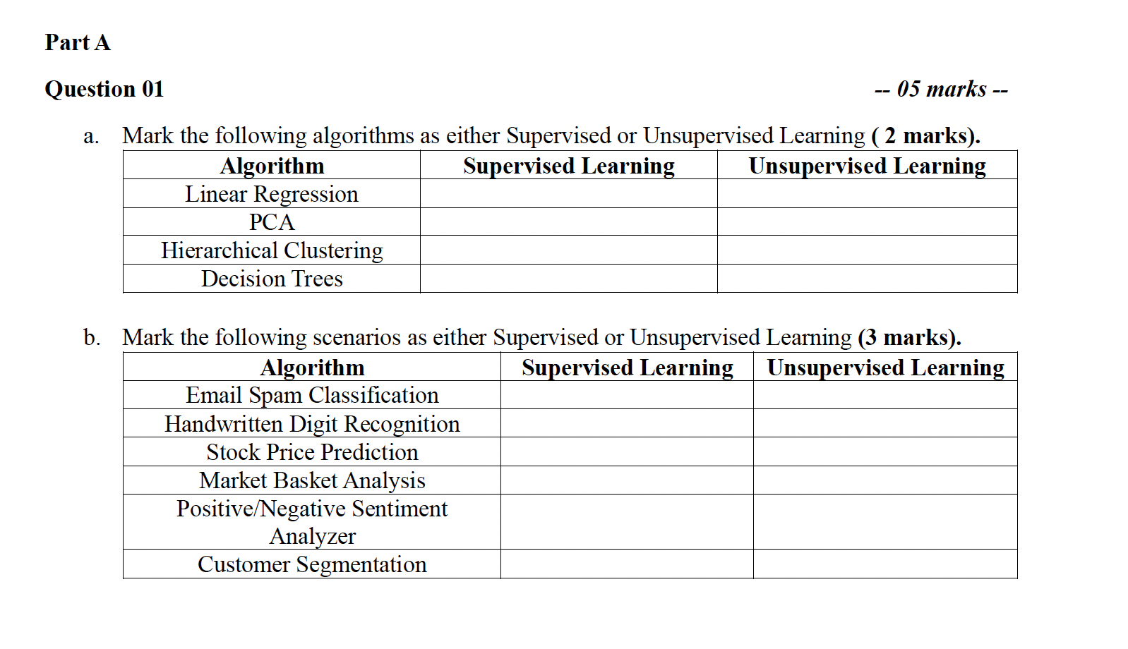

- Briefly discuss the terms “Classification”, “Regression” and “Clustering” in terms of similarities and differences among them. (3 Marks)

- “Interpretability” or “Explainability” is one of the main challenges while building machine learning models. Explain the term “interpretability” in the context of machine learning models (1 Mark) and give examples for interpretable models and non-interpretable models. (2 Marks). Also give a real-life scenario where interpretability is more important than just achieving a higher accuracy. (1 Mark)

- Explain why data normalization is important before feeding the data into the machine learning model (2 Marks). Discuss two normalization techniques briefly (2 Marks). Someone argues normalization is not needed while using complex models like neural networks. Give one fact that justifies this argument and one fact against it. (2 Marks)

